Elizabeth Gruber BAOMS Clinical Award 2016

Destination: Maxillofacial Department, University Hospital Zurich, Switzerland
Duration: Two weeks in July 2016
Requested: £250

I undertook a Clinical Observership from 4th to 15th July 2016 with Professor Joachim Obwegeser. This was based at the Kinderspital Zurich (Children’s Hospital, University Hospital Zurich) and at the Limmat Klinik, Zurich.
The two weeks were spent attending clinics and operating lists. I attended orthognathic planning clincs and saw preoperative consenting appointments and postoperative reviews. The process for orthognathic planning and pre-operative work-up of the patients was different from my experiences in the UK, with the use of 3D imaging and tracings.
I assisted in theatre for a number of procedures, including mandibular segmental distraction, SARPE, Le Fort 3 osteotomy and iliac crest graft (Pfeiffer syndrome), bimaxillary osteotomies (for cleft cases, including two-part maxilla), advancement genioplasty, primary cleft lip repair and velopharyngoplasty. The number and variety of procedures assisted with is greater than I could have expected in this time in my training. There were variations in surgical technique which I have learnt from, including positional screws for mandibular osteotomies, surgical sequencing for bimaxillary procedures and waferless surgery.
It was insightful to spend some time in a different healthcare environment and to be able to reflect on the possible advantages and disadvantages of these.
During this time I was also able to appreciate the culture of Zurich and my Swiss German has improved greatly!
I would like to thank the British Association of Oral & Maxillofacial Surgeons for providing some financial support to enable me to spend this interesting two weeks in Zurich.

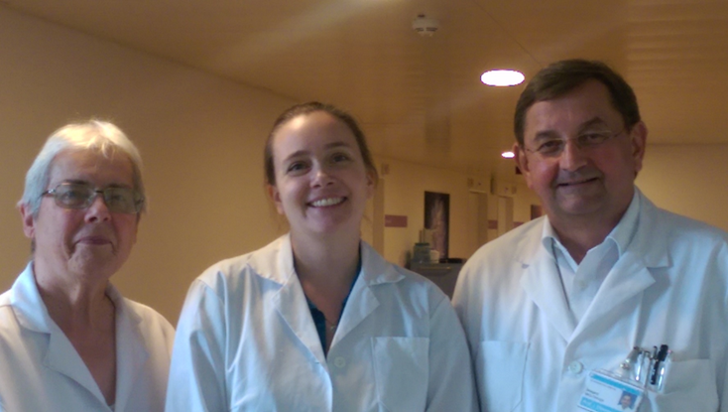
Left to Right: Dr Wanda Gnoinski (Cleft Specialist), Miss Elizabeth Gruber, Professor Joachim Obwegeser

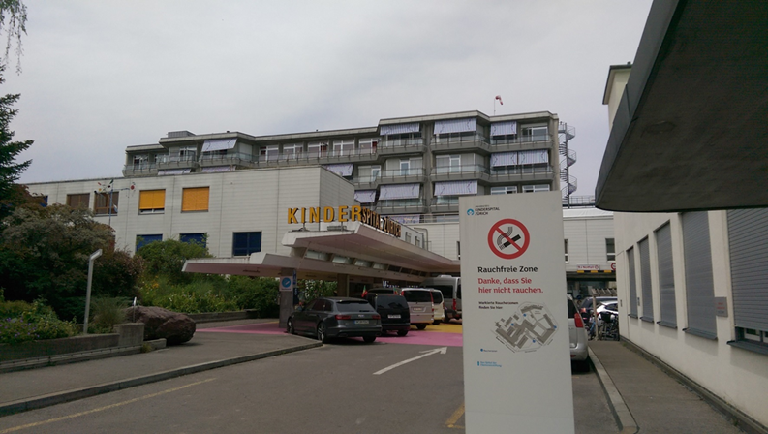
Kinderspital Zurich (Children’s Hospital, Zurich)

